Reimbursement Guide
For Reviewers
February 2024

Introduction
This document describes steps and procedures reviewers need to take to approve or reject a reimbursement request. There are two ways that a reviewer can approve a reimbursement:
- From the email notification
- From the PaperSave portal

Reviewing and Approving from Email Notification
When a request is submitted, a notification will be sent to the first reviewer on the reimbursement. Once the first reviewer has approved the reimbursement, a notification will then be sent to the second reviewer if there is a second reviewer. Each reviewer will receive an email notification that will look similar to the below:

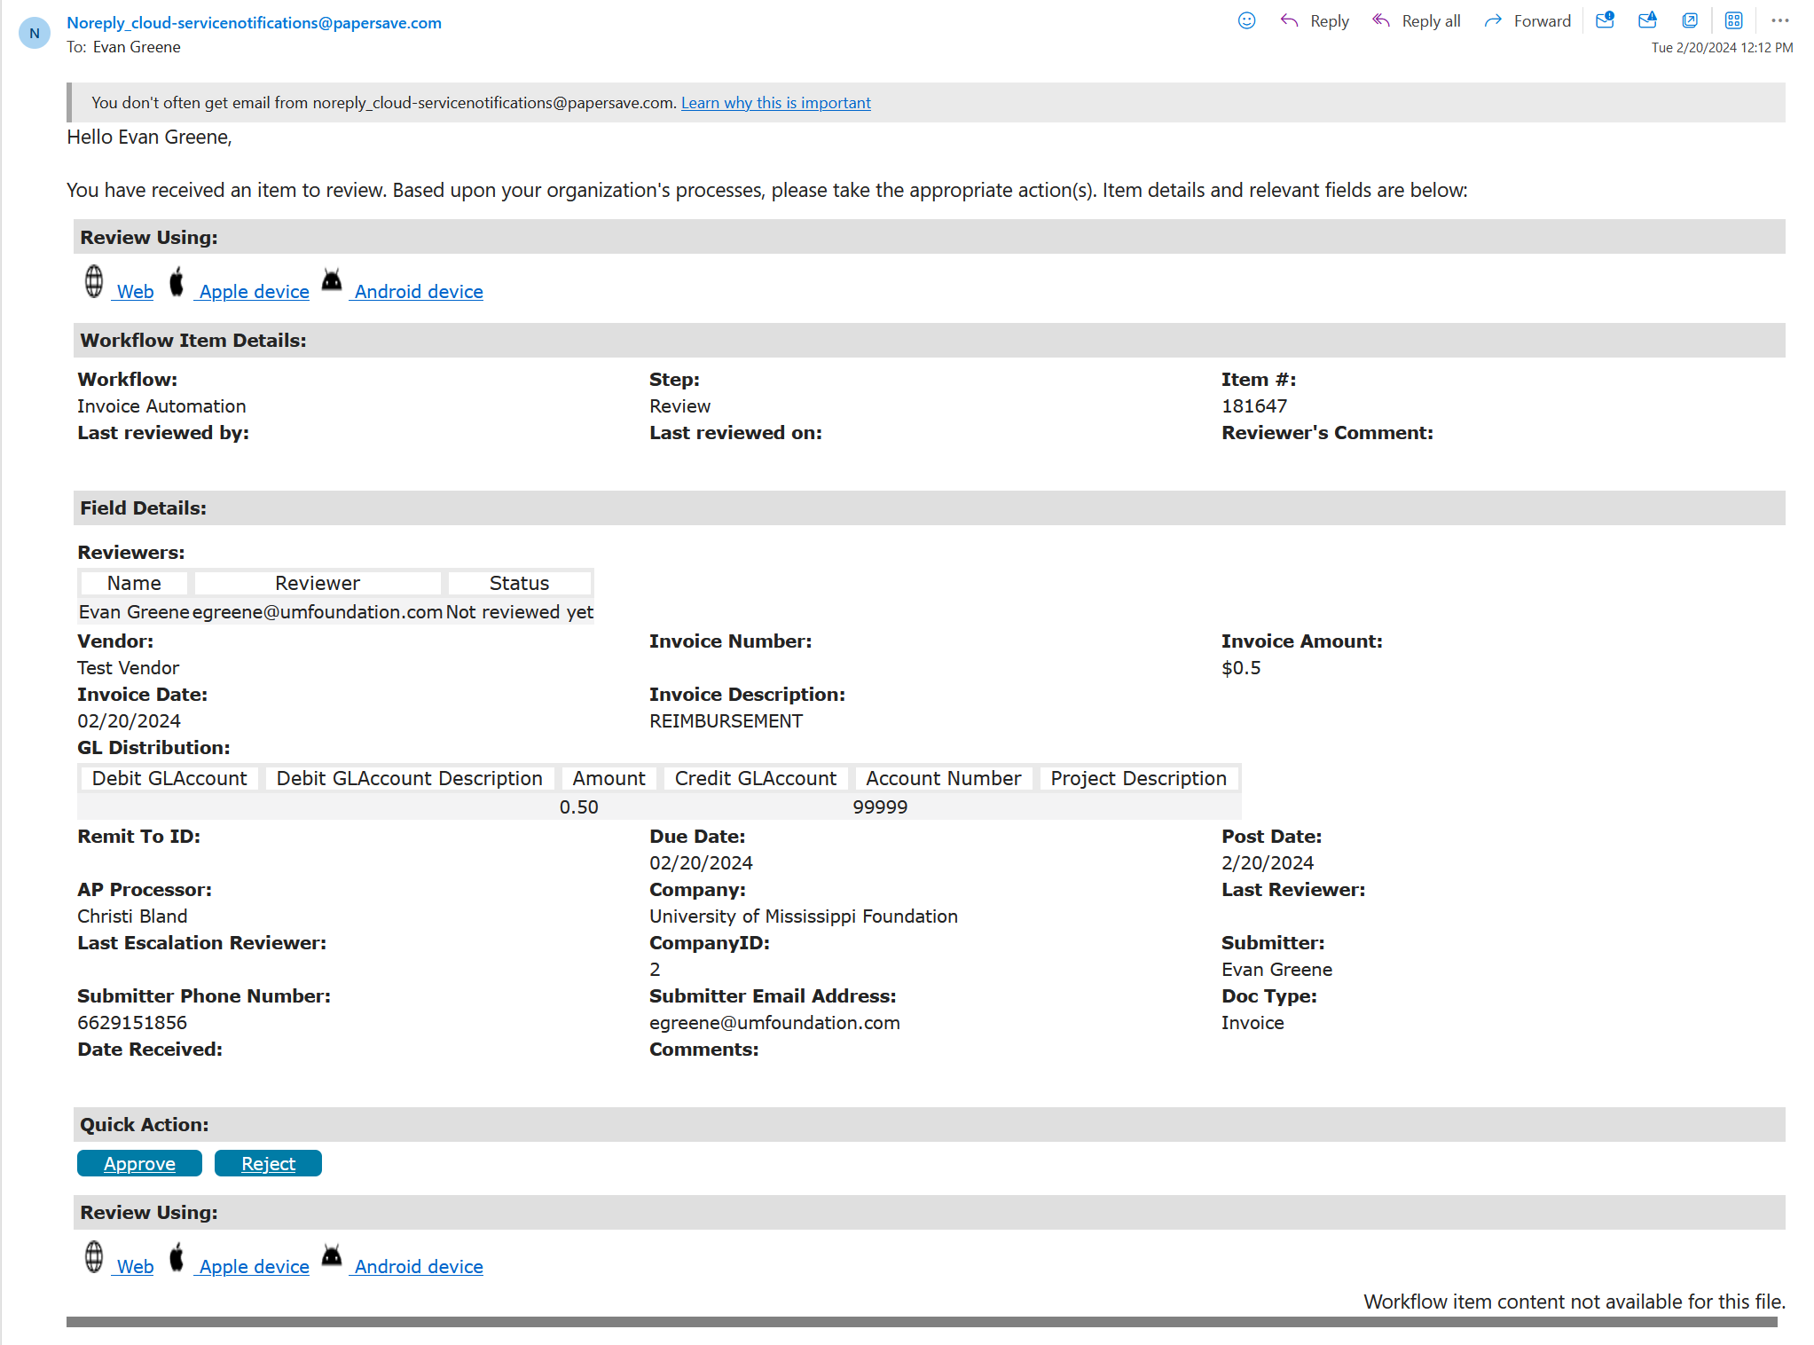
(continued on next page)

To approve this reimbursement from the email, there are a few different ways:
- Click the “Web” link
  - This will bring up your web browser where you can view the details of the reimbursement including the receipts/attachments that were included with the reimbursement.
NOTE: You may need to allow popups in your browser for the link to open.
- Click the “Approve” button
  - This will allow you to quickly approve the request. If you are familiar with the amount/vendor and are already sure that the reimbursement meets your requirements, you can click this button to quickly approve the request.

Reviewing and Approving from PaperSave Portal
In some cases, you may want to look to see what’s available to review without an email. To see what’s awaiting review, you can simply go to the PaperSave portal and check the queue.
- Go to https://umfoundation.com/papersave
- Ensure you are in the “PaperSave Automation” workflow
- Ensure you go to the “Review” step by clicking “Choose Step” -> “Review”
- Select the item you would like to review
  - Note: If the page appears to continuously load, you will need to refresh the page (as demonstrated in the video below)
- Click “Approve” to approve the request

