
Expense Management Password Reset Guide
November 2025
Go to the Blackbaud sign-in page
- Login to https://umfoundation.com/em
NOTE: Login using “Email” method if prompted and type in the email address you use for Blackbaud (this could be your @olemiss.edu or @umfoundation.com)

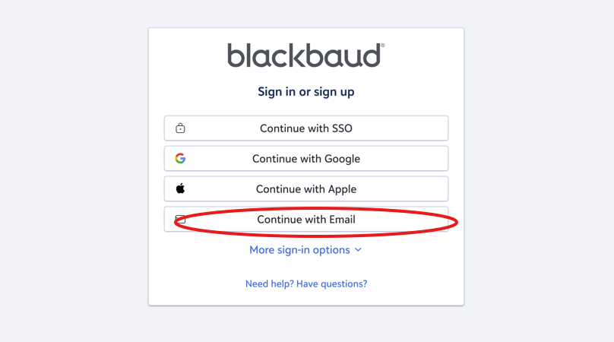

- After you type in your email address, click Continue, and then Forgot my password.

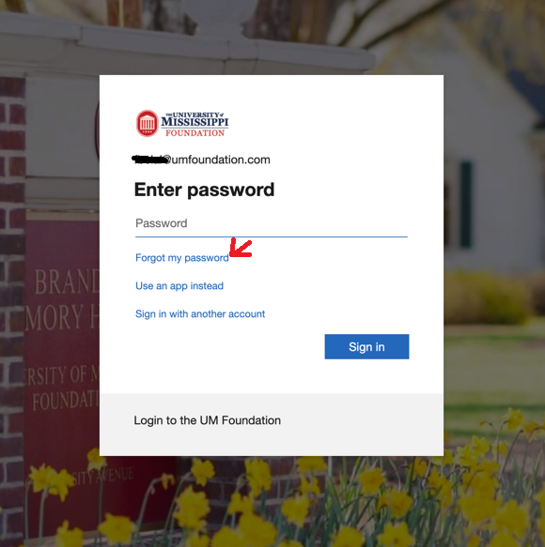

- You will be redirected to the Microsoft Online Password Reset page (Refer to screenshot below). Enter your email address again and complete the CAPTCHA to verify you’re not a robot, then click Next.

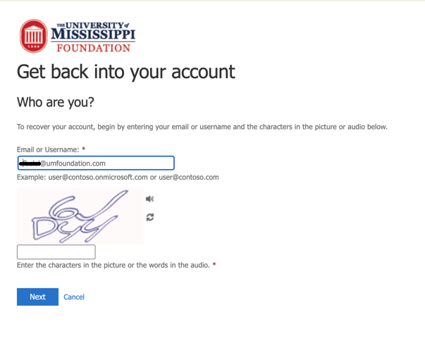

Choose a Verification Method
- After you click Next, you’ll be asked to verify your identity. Choose the first contact method for verification step 1, and follow the instructions you see on screen, then choose the second verification method for step 2 (Refer to screenshot below).

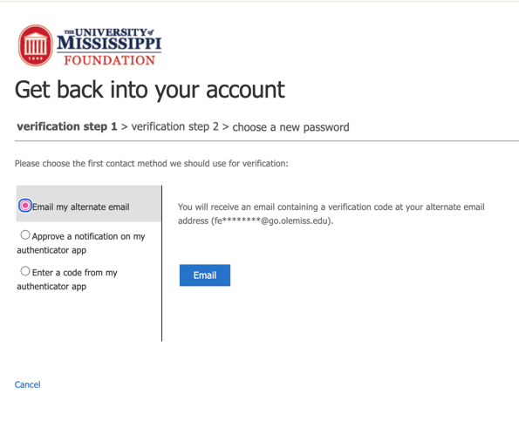

- One verified, you’ll be prompted to enter a new password in step 3. Your new password must follow the on-screen guidelines (Refer to the screenshot below). Enter your new password twice and click Finish

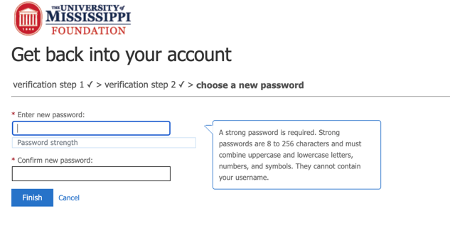

Important Note
If you’ve recently changed your phone or updated your multi-factor authentication (MFA) settings, you may not receive your verification code.
In that case, contact Blackbaud Support using the chat bot on the sign-in page.
If you don’t receive a response through the chat bot, please submit a ticket to the IT Helpdesk for further assistance.

