Reimbursement Guide
November 2023

Introduction
This document describes steps and procedures for creating a reimbursement request for the University of Mississippi Foundation utilizing the new PaperSave system.

Fill Out Reimbursement Form
- Go to www.umfoundation.com/services
- Under “UM Employee Forms” click “PaperSave Reimbursement Form” to open the Reimbursement Form
- Fill out the form and save it to your computer. *All fields are required*
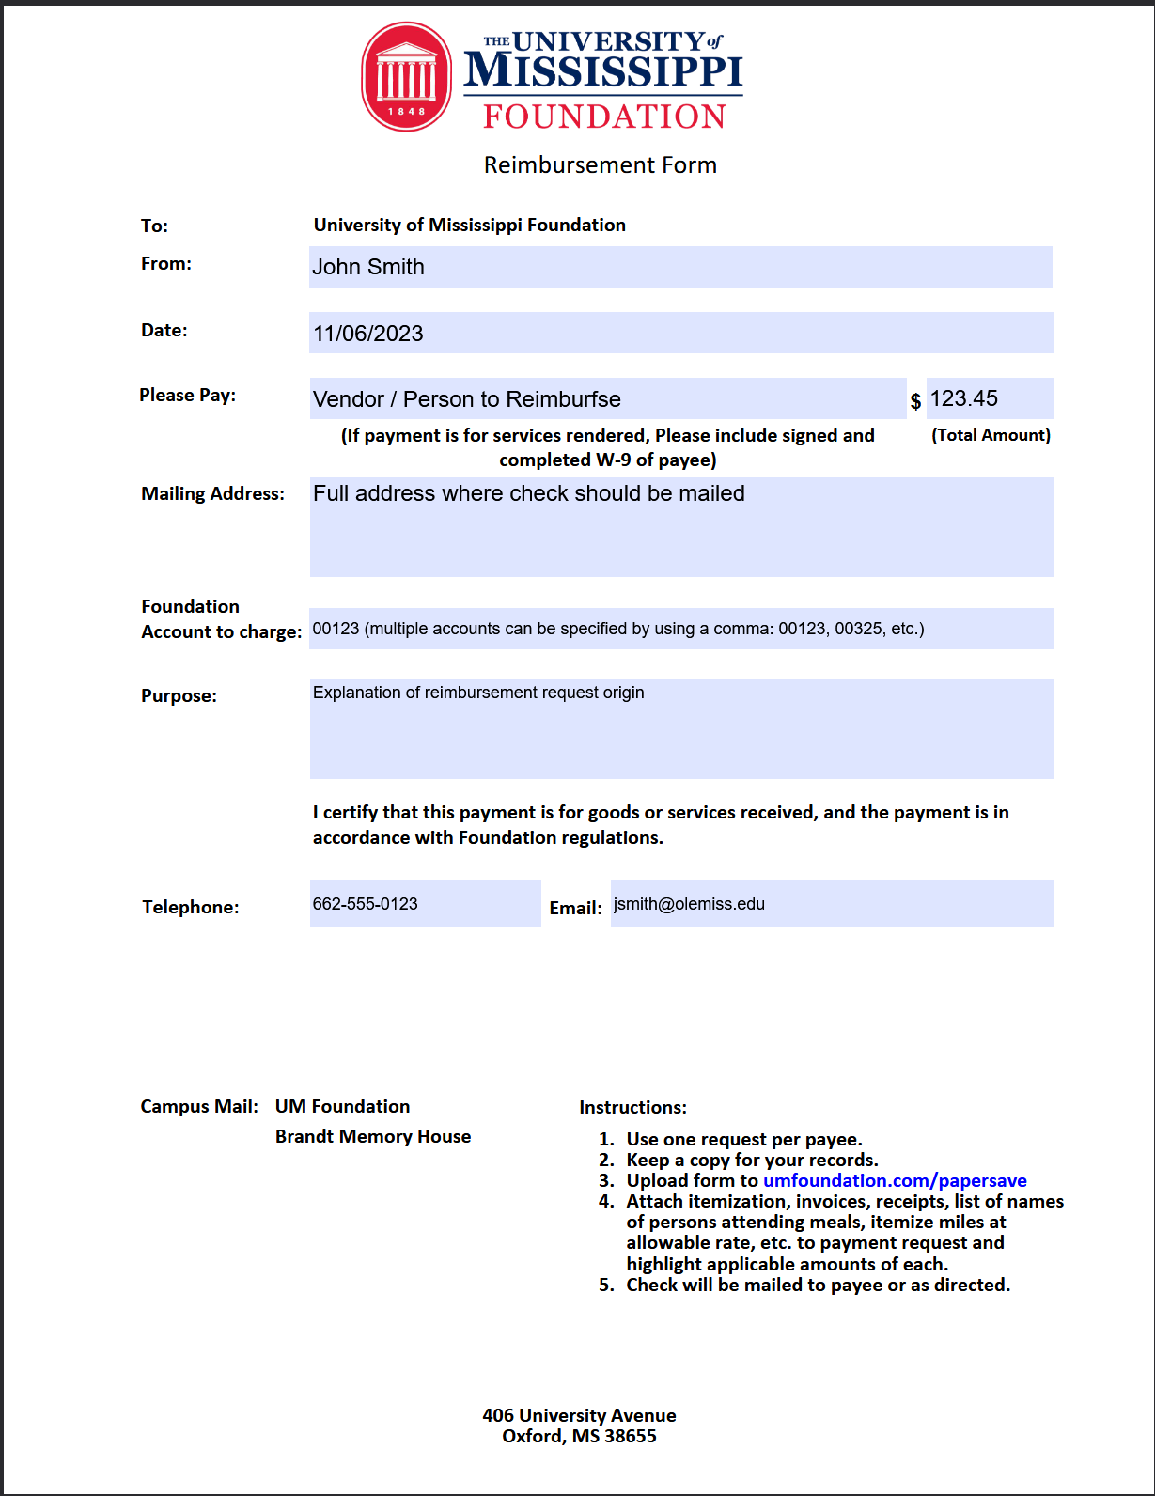

Login and Configure PaperSave
- Go to www.umfoundation.com/papersave
- Log into PaperSave using your @umfoundation.com account
(For issues with logging in, contact support@umfoundation.com)
NOTE: If you see “Approval Required” screen, this is because you’re logged in under your @olemiss.edu account. You should click on “Sign in with another account” and login with your @umfoundation.com credentials.
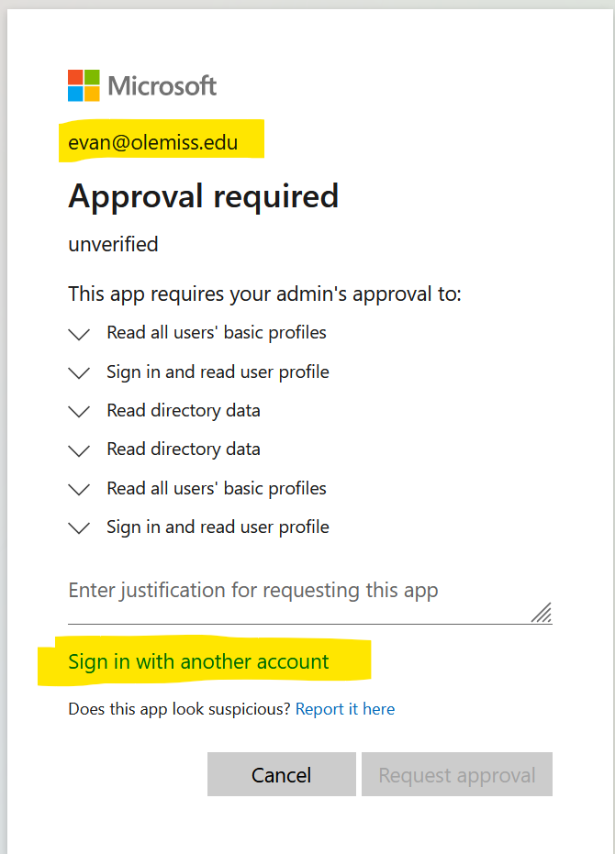
- (First time only) Hide the “Quick Walkthroughs” ribbon if it’s shown. (Green ribbon on the right).
  - Click the “Gear” icon
  - Toggle “Show Quick Walkthroughs Tab” off
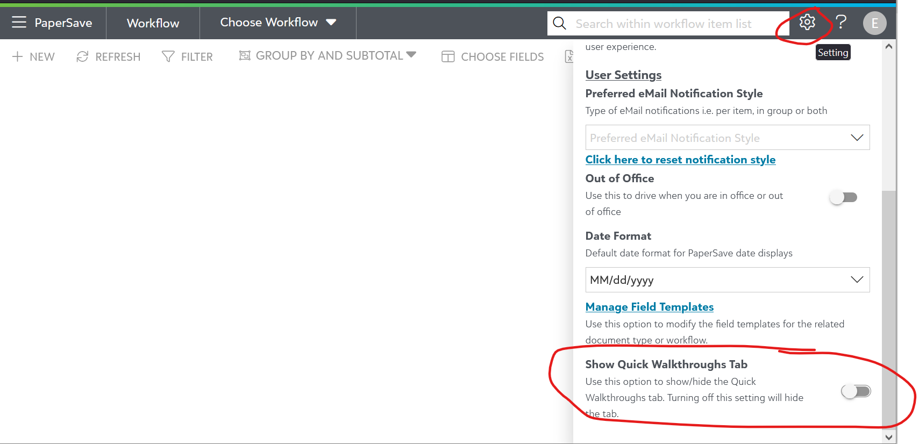
- (First time only) If “Choose Workflow” is shown in the top menu, you need to do the following.
  - Click “Choose Workflow”
  - Click “Invoice Automation” (do not select any of the sub-options)
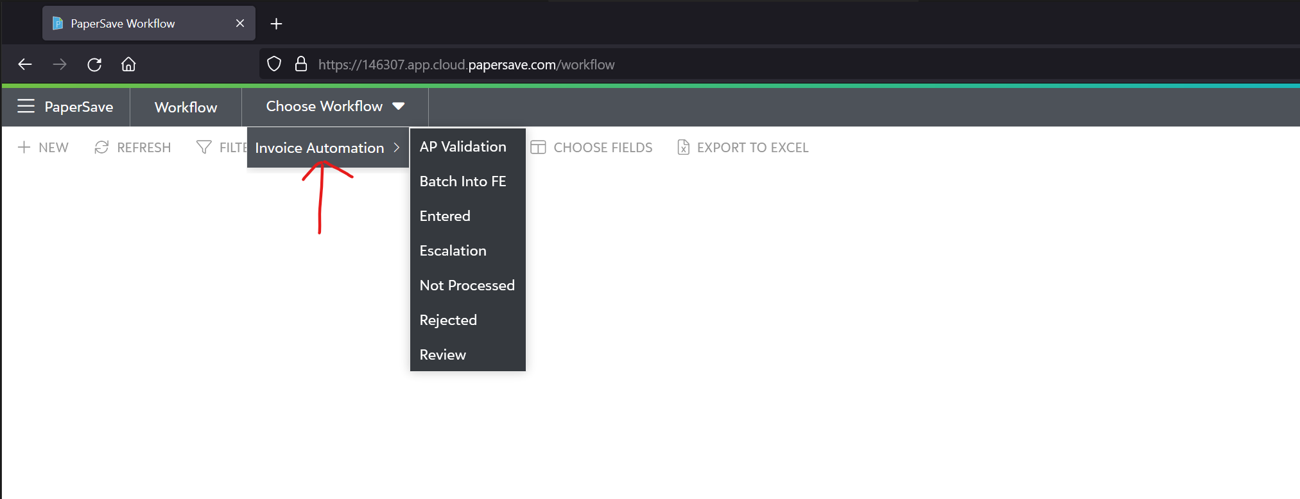

- Please ensure Invoice Automation is selected right next to WorkFlow

Submit a New Reimbursement
- Click “+ NEW” button
- Click or Drag in ONLY your UM Foundation PaperSave reimbursement form you filled out in step 1 and wait until the status says “OCR Completed”

- Add supporting documents (invoices, receipts, etc) by clicking on “Add more pages”

- Add “Reviewers” to the reimbursement.
(Reviewers are who sign off/approve the request. EG: Supervisor, Manager, etc)
  - Under “Reviewers”, Click “+ Add”
  - Begin filling out the “Name” of the reviewer and select them from the list
(If you do not see your reviewer pop up, please contact support@umfoundation.com)
  - Click the “Disk” icon to save
NOTE: Do NOT modify the “Status” or “Reviewer” boxes

(continue on next page)

- Add “GL Distribution” Information
  - Under “GL Distribution”, click “+ Add”
  - Fill out the “Amount” so that it matches the reimbursement for the account
  - Fill out “Account Number” to your 5 digit account/allocation number.
NOTE: If multiple accounts need to be reimbursed, you will need to enter a new line for that account number by following steps a-c for the additional account. (See screenshot below for example)
  - Be sure to leave the other fields blank.
(“Debit GLAccount”, “Debit ALAccount Description”, “Credit GLAccount” should all be blank)
  - Click the “Disk” icon to save.
- Review and update all remaining fields for the reimbursement in the form on the right and then click “Submit Item”
  - Vendor: Should be the person/entity that’s being paid
  - Invoice Number (Optional)
  - Invoice Amount: Full Amount on Reimbursement Request
  - Invoice Date: Date of Invoice
  - Invoice Description: Leave as is (REIMBURSEMENT)
  - Remit To ID: Address of the entity being paid
  - Due Date
  - Post Date: Today’s date
  - AP Processor: Leave as is
  - Last Reviewer: Leave blank
  - Last Escalation Reviewer: Leave blank
  - Submitter: Leave as is. (should already be your name or Foundation account username)
  - Submitter Phone Number: Your office/preferred phone number
  - Submitter Email Address: Your work email address (@olemiss.edu)
  - Doc type: Leave as is
  - Date Received: (Optional) When the invoice is received.
You should see “1 Workflow item(s) successfully submitted"

